The university of Azad Jammu and Kashmir ,
Muzaffarabad

Name | Adeela Bashir
Roll no | 2024-SE-12
Course Title | Computer networks
Lab | Switching and ARP
Submitted to | Dr. Asma javeid

Department of Software Engineering

Switching and ARP (MAC Address Learning)

Objective
The objectives of this lab are:
- To understand switching in computer networks.
- To learn how switches forward frames using MAC addresses.
- To understand the ARP (Address Resolution Protocol) process.
- To observe MAC address learning behavior in a switch.
- To learn how to check and clear the MAC address table.

Introduction
A switch is a Layer 2 networking device used to connect devices in a local area network (LAN). It forwards data frames using MAC addresses. When a switch receives a frame, it checks its MAC address table to determine the correct destination port.
ARP (Address Resolution Protocol) is used to map an IP address to a MAC address before communication takes place between devices. During communication, the switch learns MAC addresses automatically and stores them in the MAC address table.
In this lab, a simple network was created using two PCs and one switch to study switching and ARP behavior.

Devices Used
The following devices were used in this lab:
3 PCs
2 Switches
Copper Straight-Through Cables
Copper Cross-Over Cable

Network Topology
The network topology consists of:
PC0 connected to Switch0
PC1 connected to Switch0
Switch0 connected to Switch1
PC2 connected to Switch1
PC-to-switch connections were made using straight-through cables, while switch-to-switch connection was established using a cross-over cable.
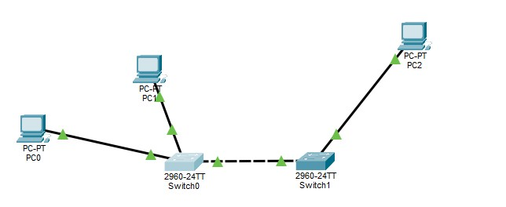

IP Addressing Table

Device | IP Address | Subnet Mask
PC0 | 192.168.1.1 | 255.255.255.0
PC1 | 192.168.1.2 | 255.255.255.0
PC2 | 192.168.1.3 | 255.255.255.0

Procedure

Step 1: Create Network Topology
Cisco Packet Tracer was opened and a new workspace was created. Three PCs and two switches were added to the workspace.

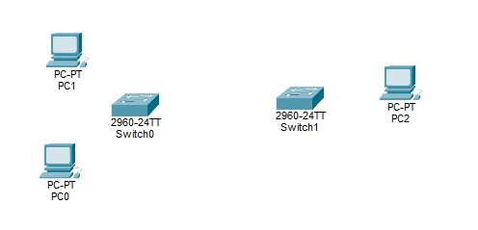

Step 2: Connect Devices
The devices were connected using Copper Straight-Through and Cross-Over cables.
Connections:
- PC0 to Switch0 using Straight-Through Cable
- PC1 to Switch0 using Straight-Through Cable • Switch0 to Switch1 using Cross-Over Cable
- PC2 to Switch1 using Straight-Through Cable

Step 3: Configure IP Addresses
IP addresses were assigned to both PCs.

PC0 Configuration
- IP Address: 192.168.1.1
- Subnet Mask: 255.255.255.0

PC1 Configuration
- IP Address: 192.168.1.2
- Subnet Mask: 255.255.255.0

PC2 Configuration
- IP Address: 192.168.1.3
- Subnet Mask: 255.255.255.0
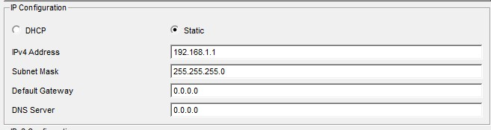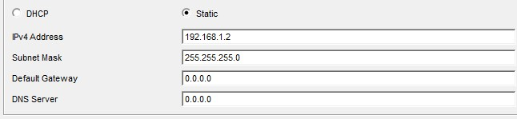

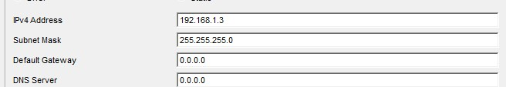

All systems were configured in the same network.

Step 4: Check MAC Address Table Before Communication
The switch CLI was opened and the following command was executed:
• show mac address-table
Initially, the MAC address table was empty because communication had not started yet.

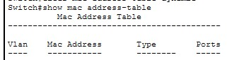

Step 5: Test Communication Using Ping
The Command Prompt of PC0 was opened and the following command was used:
- ping 192.168.1.2
- ping 192.168.1.3
The first ping request took some time because the ARP process was performed first. After ARP resolution, communication became successful.

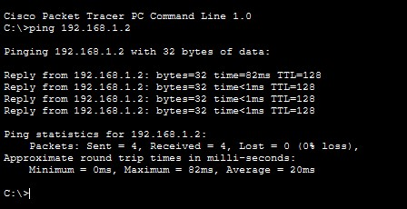
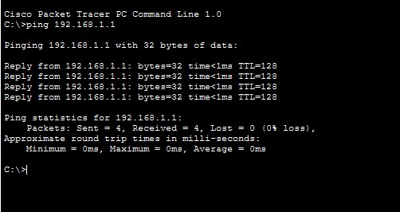

Step 6: Verify MAC Address Table

The switch CLI was opened again and the following command was executed:
• show mac address-table
After successful communication, both switches learned the MAC addresses of connected devices automatically and stored them in their MAC address tables.
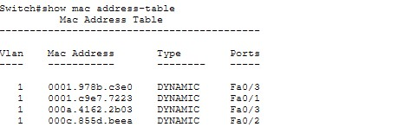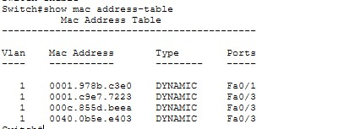

Step 7: Clear MAC Address Table
The following command was used to clear dynamic MAC entries:
• clear mac address-table dynamic
After clearing the table, the show command was executed again to verify that the learned entries were removed.

Switch0:
Switch1:

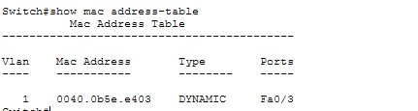

ARP Working Explanation:
ARP stands for Address Resolution Protocol. It is used to find the MAC address of a device when its IP address is known.

The ARP process works as follows:
- The sender device checks whether the destination MAC address is available.
- If the MAC address is unknown, the sender broadcasts an ARP request.
- The destination device replies with its MAC address.
- The sender stores the MAC address in its ARP table.
- Communication starts successfully.

MAC Address Table Explanation
The switch stores learned MAC addresses in a MAC address table, also known as the CAM table. Whenever a device sends frames through the switch, the switch learns the source MAC address and associates it with the connected port.

This process helps the switch forward frames efficiently without flooding unnecessary traffic.

Commands Used

- Show MAC Address Table
- show mac address-table
Purpose: Used to display learned MAC addresses on the switch.
- Clear Dynamic MAC Table
- clear mac address-table dynamic
Purpose: Used to remove dynamically learned MAC addresses from the switch.
- Ping Command
ping 192.168.1.2
Purpose: Used to test communication between two devices.

Observations
- Initially, the MAC address tables were empty.
- After pinging, both switches learned MAC addresses automatically.
- ARP resolved IP addresses into MAC addresses.
- Communication between all PCs became successful.
- Switches forwarded frames between networks correctly.
- The MAC address tables were cleared successfully using the clear command.

Result:

The lab was completed successfully. Switching behavior, ARP process, and MAC address learning were observed and verified using switch commands.

Conclusion:

In this lab, an extended LAN network was created using three PCs and two switches. IP addresses were configured successfully, and communication between all systems was tested using ping commands. The switches learned MAC addresses dynamically and stored them in their MAC address tables. The ARP process, MAC learning behavior, and frame forwarding between switches were successfully observed. The MAC address tables were also cleared and verified successfully.

